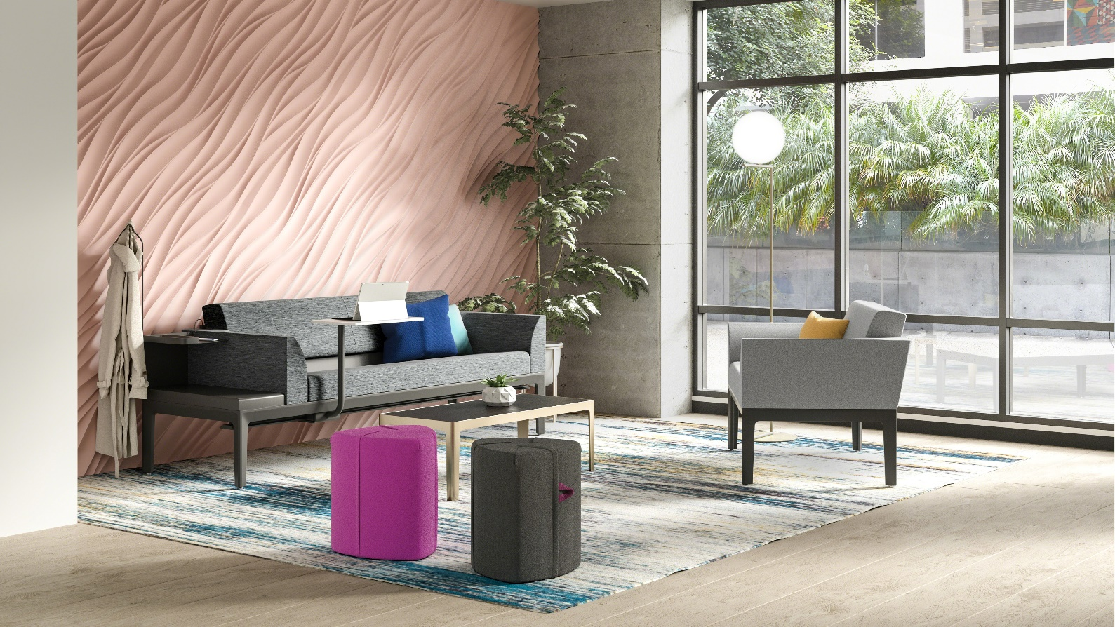

Surround
technical cut sheet

Family and friends are critical to a patient’s health and well-being, and support for them in the patient room is essential. A lack of support can lead to discomfort and exhaustion, which can create obstacles and frustration for the clinician, and compromise care for the patient.
Surround—a series of versatile lounge seats and sleepers—supports the family, friend, and patient experience in every way, offering a place to spend time with one another, rest and relax, be productive, host guests, and communicate with clinicians.

OVERVIEW

Surround was thoughtfully designed with features like a high-recline arm, integrated sliding table, and open, intuitive storage to provide optimal comfort for family and friends while they’re supporting the patient.
Surround’s high-recline arm supports resting postures so visitors can relax comfortably.
Surround’s short arm provides eleven additional inches of sleep surface when the sleeper’s back is deployed for a comfortable night’s sleep, even in small spaces.
A softer seat cushion is offered for a comfortable long-term sit.
Glides, locking, and non-locking directional casters are offered to allow ease of mobility to clean behind.
An integrated sliding table offers a convenient surface for dining or note-taking during clinician consultations.

Personal items, like purses and technology, are easily stowed within arm’s reach in open, intuitive storage.
Easy-access power and USB ports allow devices to charge during use, keeping the patient room floor open and free of cables.

Surround’s built-in, fold-down sleeper provides family and friends with simple, comfortable sleeping accommodations with a minimal footprint and no extra clutter.
An integrated coat hook keeps personal belongings both nearby and out of the way.

Surround’s tall, open base helps create a frame that moves easily during cleaning, with ample height clearance for mop and broom handles to reach underneath.

A built-in storage tray for small personal items has a picture rail that props up and displays patients’ cards, artwork and photographs.

FRAME
Frame

- Overall depth is 27.5"
- 11 widths between 44" and 104.5" in 5.5" increments
- Height to underside of frame with table rail is 9" and without table rail is 11"
- Leg height is 14"
- Frames are dynamically tested to 550 lbs. and statically tested to 750 lbs. in all seating positions
- Adjustable glides are standard and directional locking and non-locking casters are available as an option for mobility
- Base frame glides have a 1.5" adjustment; glides are constructed of steel with a nylon over molded glide foot that is 1" in diameter and available in platinum finish only
- Integrated sliding table option requires specifying the frame with table rail
- Frame understructure features welded assemblies of steel tubing, 1" x 2" x 16 ga. (.059") thick
- Die-cast aluminum legs are attached to the steel frame with bolts at each corner of the frame
- Aluminum extrusions span each corner leg to lock in components with table rail

Note: For detailed dimensions, reference “Surround Height Diagram” and “Surround Actual Dimensions” in the Steelcase Health Volume 1 Seating Specification Guide.

9" clearance

Directional casters

Leg height 14"

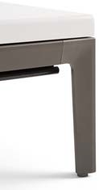

SEAT AND BACK CUSHIONS

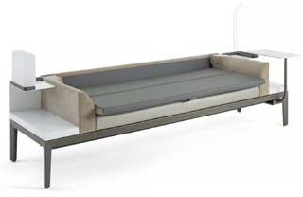
- Seat cushion depth is 18.5", sleep surface depth is 28" and overall unit depth is 31"
- 9 widths between 33" and 77"
- Height to top of back is 31.5"
- Seat and back cushions in widths of 55", 60.5", 66", 71.5" and 77" have a single center seam
- Seat cushions have a 7° recline, and back cushions have an 18° recline
- Crumb sweeps are located on all three sides of seat cushions
- Unit includes a structural outer back and an upholstered back cushion
- Sleep surface is standard on 71.5" and 77" back cushions
- Sleep surface is optional on 55”, 60.5", and 66" back cushions
- Sleep surface extends 2" beyond seat edge
- Seat cushion is offered in a standard and softer foam durometer
- Sleep surface material is a urethane-coated 200D Nylon Oxford material in Merle Grey

ARMS

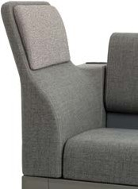
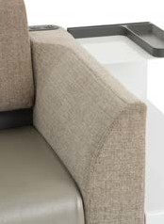
- Low arm is 31"D x 5.5"W x 12.5"H
- Short arm is 31”D x 5.5”W x 12.5”H
- High-recline arm is 31"D x 5.5"W x 23"H
- High-recline arm extends 3.75" beyond the frame at the outermost edge
- Low arms and high-recline arms are available in right- or left-facing positions
- High-recline arm is standard with an integrated pillow and is available with contrasting upholstery options
- No arms, one arm or two arms can be specified
- Sleeper suites require two arms for sleep surface attachment
- Adjacent arm must be specified when adding a two-tier storage option
- Arms must be specified with or without power

POWER

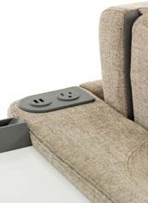
- Power can be placed in low- and high-recline arms
- Power options include two standard 110V outlets, one standard 110V outlet and two USB ports, or four USB ports
- Power outlets are standard 110V outlets and are not hospital grade; if hospital grade is required, please specify the four USB port power option
- Each USB port is fast-charging USB A with two amps
- Maximum of four USB ports may be specified per unit
- Power options are tamper- and spill-resistant
- One-arm units specified with two standard power option and two-arm units specified with two standard power option in one arm and no power in the other will have an 8' power cord that exits the lower center back of the arm specified with power
- One- or two-arm units specified with any other power option except two standards in one or both arms, will have an 8' power cord exiting the lower center back of the unit
- Steelcase recommends checking with all local and facilities authority’s specific to the installation to confirm acceptance of proposed product and applications

STORAGE END TABLES

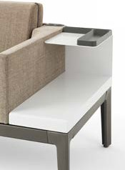
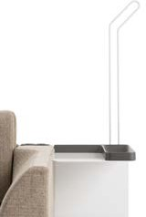
- Storage end table is available in a one- or two-tier option
- Storage end table mounts to the left or right side of the frame
- Storage is available in 11"W and 16.5"W
- Two-tier storage end table offers coat hook options
- Coat hook extends 2" from the frame
- Two-tier storage end table comes standard with a picture rail and storage tray
- Storage end table is constructed of powder-coated, formed steel for efficient cleaning and durability
- Coat hook is a formed continuous loop of 5/16" steel rod that mounts to the back of two-tier storage on-site

INTEGRATED SLIDING TABLE

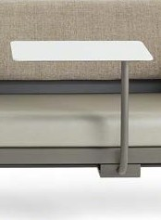
- Tables are 12"D x 19.5"W and pivot 360°
- Table surface is injection molded and vibration welded to create a barrier against moisture
- Only one table is available on each Surround unit
- Table arm and surface are ordered separately and must be mounted to the frame on-site
- Table surface is positioned 10" above the seat cushion
- The minimum the sliding table adds to the overall depth of a unit is 6" (when it’s turned so the tablet surface is over the seat)
- The maximum the sliding table adds to the overall depth of a unit is 20" (when the table is turned 180° from the previous and facing away from the seat)
- Table arm slides along the rail the length of the frame
- Table rails have stops to ensure no interference with a high-recline arm
- Load testing: 100 lbs. no damage at all; 300 lbs. safe, yielding failure mode
- Cycle testing: 70K times = 8' ten times per day, every day for ten years

FINISHES

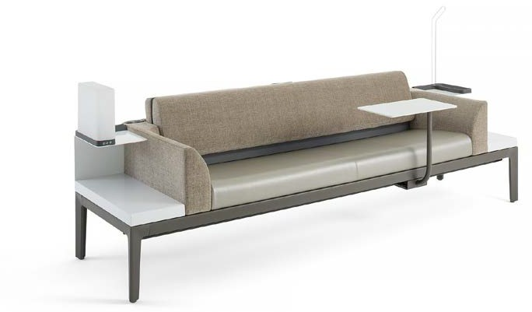 UPPER STORAGE + COAT HOOK (Tray always Merle) 7245 Carbon Metallic
7241 Arctic White
7243 Seagull
7360 Merle

STORAGE TABLE (Lower storage, without upper tier) 7245 Carbon Metallic
2
7241 Arctic White
7243 Seagull
7360 Merle

FRAME
3
4140 Arctic White Gloss
4728 Nickel Metallic 3
4743 Mineral Metallic
4744 Pearl Metallic
4750 Champagne Metallic
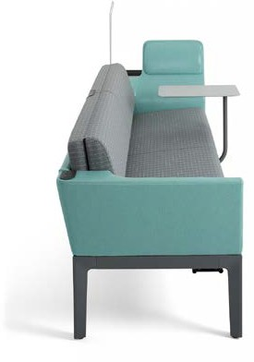4752 Steel Metallic 4788 Gold Dust Metallic 4798 Sterling Metallic
E
4799 Platinum Metallic 4803 Near Black Metallic 7245 Carbon Metallic
7246 Midnight Metallic
0835 Black
4242 Milk Smooth
7207 Black
7236 Fog
7237 Slate
7238 Fieldstone
7239 Midnight
7241 Arctic White
7243 Seagull
7278 Dark Bronze
7360 Merle

TABLET SURFACE
4
6527 Merle
6009 Arctic White
6053 Seagull

TABLET ARM
5
7245 Carbon Metallic
7241 Arctic White
7243 Seagull
7360 Merle

PILLOW FINISH
INNER BACK FINISH OUTER BACK FINISH SEAT FINISH
E
ARM FINISH

PRODUCT AND TESTING CLEANING

Surround seating components completed a rigorous and varied testing protocol to demonstrate the strength, durability, and stability of the product over its life. Surround components meet or exceed the following:
- ANSI/BIFMA X5.4-2012 and X5.5-2008
- Cushion padding and fabric will comply with BIFMA First Generation Voluntary Upholstered Furniture Flammability Standard, as well as the state of California Technical Bulletin 117
- Fabric is tested for abrasion, stain resistance, and durability
- Static load tests place a single large weight on the chair seat for a set period with no additional force or movement applied
- Surround seating static load: 750 lbs. per seating position
- Dynamic load tests combine both the weight and the motion of sitting to represent a more realistic situation. Dynamic testing not only tests the repeated “in and out” load in the chair seat, but also the forces applied to the arms and back by people in different postures, to replicate real life more closely
- Dynamic load: 500 lbs. per seating position
Environmental requirements continue to become more important in the healthcare market. Every effort is being made to ensure Surround’s materials are healthcare appropriate (durable and long-lasting to withstand extreme usage and harsh chemical cleaners) and still meet environmental requirements. The product is being tested with commonly used healthcare cleaners as well as stringent simulated uses to ensure it will stand up to the harsh chemicals and the rigors of a 24/7 environment.

WARRANTY

Lifetime warranty that product is free from defects in materials and workmanship (includes shipping, parts, and labor for the repair or replacement of defective item). See complete warranty for exceptions.
Complete warranty coverage is available online or upon request.

X5.4-2012 TEST SUMMARY

- Back strength: horizontal forces at 300 lbs./seat (900 total) and vertical forces at 500 lbs./seat (1,000 total)
- Back durability: horizontal forces at 150 lbs./seat x 120,000 cycles and vertical forces at 300 lbs./seat x 10,000 cycles
- Arm strength: horizontal and vertical forces at 300 lbs. in and out
- Arm durability: horizontal forces at 100 lbs. x 50,000 cycles and vertical forces at 300 lbs. x 10,000 cycles
- Integrated sliding table: 70,000 cycles with 7 lbs. over 30" travel, 300 lbs. proof load, and 100 lbs. functional load
- Seating durability: 210 lbs. cycled 100,000 times per seat with 500 lbs. in an unoccupied seat (static)
- Drop test: 550 lbs. dropped from 2"
- Stability test: ensure the product does not tip with shifts in weight

RESPONSIBLE DESIGN—SUSTAINABILITY

Through design, manufacturing, delivery and product life cycle– we have considered the impact of Surround on the environment and uncovered opportunities to make things better. Surround’s design considers the reuse of the components over its life, and the ability to recycle and use recycled content, as well as the appropriate use of packing materials.
Environmental requirements continue to become more important in the healthcare market. Every effort is being made to ensure Surround’s materials are healthcare appropriate (durable and long lasting to withstand extreme usage and harsh chemical cleaners) and still meet environmental requirements. The product is being tested with commonly used healthcare cleaners as well as stringent simulated uses to ensure it will stand up to the harsh chemicals and the rigors of a 24/7 environment. Surround is recyclable, and to simplify recycling, we minimize co-mingled components, consider the number and type of fasteners, and are committed
to making disassembly easy with common hand tools. Adhesives are eliminated if possible. The components are all replaceable, which allows a facility to revitalize the unit by purchasing replacement parts instead of having to dispose of the damaged unit and buy new. Painted components are coated with powder-coat paint, which results in minimal waste, consumes less energy and requires no solvents, compared with traditional wet paint processes.
The LEED® (Leadership in Energy and Environmental Design) Green Building Rating System is a voluntary, consensus- based national standard [created by the U.S. Green Building Council (http://www.usgbc.org)] for developing high- performance, sustainable buildings. One important extension of our commitment to the environment is in supporting the
U.S. Green Building Council’s LEED program. While all Steelcase products will help contribute to point acquisition, it is important to note that no individual product can be LEED certified or guarantee the acquisition of LEED points.
Surround meets the Healthier Hospitals Safer Chemicals Challenge and SCS Indoor Advantage Gold certifications for indoor air quality in North America. Surround is level 3 certified to ANSI/BIFMA e3 standard.

Call 800.333.9939 or visit SteelcaseHealth.com
facebook.com/SteelcaseHealth twitter.com/SteelcaseHealth youtube.com/SteelcaseTV
12/14 ©2024 Steelcase Inc. All rights reserved. All specifications subject to change without notice. Trademarks used herein are the property of Steelcase Inc. or of their respective owners.

