Dear: [INSERT NAME HERE],
The purpose of this communication is to call your attention to a Product Safety Recall Notice regarding the LightCorp LSL18YA LED Shelf Light with 40W Power Supply requiring your immediate attention.

There is a potential fire hazard with the 40W GlobTek, Inc. power supply with lot codes 0711, 1311, 2111, 3711, and 4311 that came with LSL18YA LED Shelf light fixtures sold by Steelcase between March 30, 2011, and December 30, 2013.

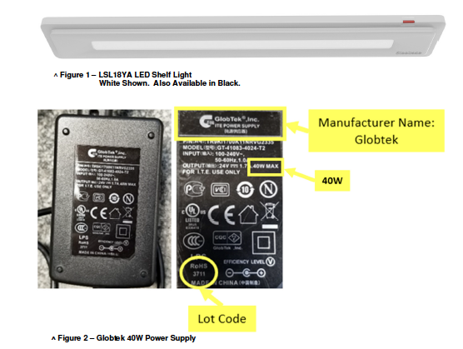
Our records indicate that you purchased and received this product during this time, and therefore you may have defective products that need to be uninstalled and discarded.
Please review the Product Safety Notice from the LightCorp website. It explains what you need to do to safely address this issue.
LightCorp and Steelcase apologize for any inconvenience this issue may cause.
Sincerely,
[INSERT DEALER SIGNEE’S NAME]
[INSERT SIGNEE’S TITLE]

