Situation

Steelcase has decided to recall and retrofit the Coalesse Bindu Guest chair (model number CO200G BINDU LOW BACK GUEST CHAIR, CO300G BINDU MID BACK GUEST CHAIR) produced between September 1, 2019 and February 10, 2020 due to improper fasteners used to connect the chair back to the chair base. There is a potential for these fasteners to fail during use, creating a rearward fall hazard.

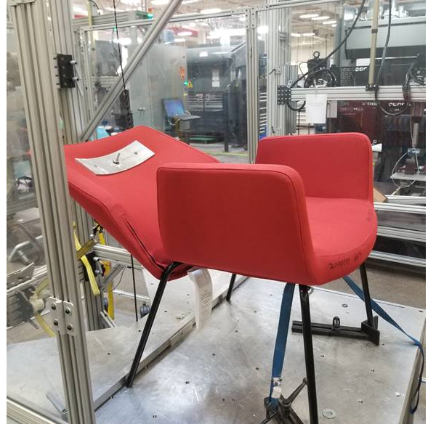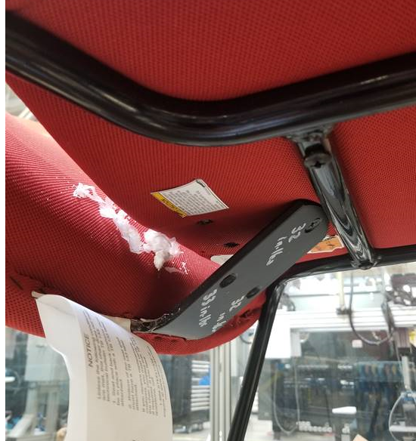
Figure 1 - Bindu Guest chair failure example Figure 2 - Bindu Guest chair base

Required action

To ensure your customers’ safety and satisfaction with their Bindu Guest chair, dealers will replace the bottom bracket fasteners with new fasteners. A written summary of the retrofit work is provided below. We ask that all dealers inform their customers of this recall and schedule a time to complete the retrofit work. The Steelcase Recall team will email your recall coordinator and Operation leader the following items in the coming days to assist you with informing your customer:
- This Safety Recall Notice
- Order search information for your customers that includes service request (SR) numbers for each site
- Dealer to customer letter describing the recall
- Frequently Asked Questions (FAQ)

Retrofitting process

The Bindu Guest chair retrofit consists of removing three fasteners from underneath the chair seat in a specific order and installing three new fasteners at a specific torque.
Existing fasteners must be replaced with new fasteners and the retrofit instructions below must be followed. The retrofit will consist of the follow steps:
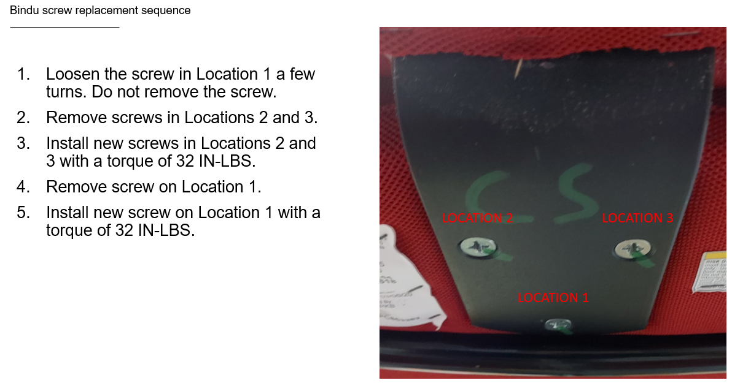
Figure 3 - Bindu Guest chair retrofit example

Steelcase will provide a reimbursement for travel, labor, parts disposal and administrative costs incurred at customer sites.
Key items to note:

- Dealers seeking reimbursement should complete the LASER labor request form using the service request numbers provided in the order search spreadsheet. Please pay special attention to ensure that no critical fields are left blank.
- Fasteners to complete the retrofit work cannot be ordered via Hedberg. Dealer coordinators will need to contact Steelcase for screws and labels. New fasteners may be ordered by contacting a Steelcase recall coordinator at 1-800-210-5109 or retrofits@steelcase.com. Steelcase will generate the orders and arrange for shipment.
- Given the nature of the work, damage to the existing chair should be minimal or non-existent. If damage occurs, the request for replacement will be evaluated on a case-by-case basis.
- Reimbursement is limited to the work described in this Safety Recall Notice.
Our goal is for dealers to complete this work by March 31, 2021. Due to COVID-19 executive orders and possible travel limitations, the time to complete this retrofit may be extended. We apologize for any inconvenience this recall may cause and appreciate your support as we work through this issue together.

Steelcase has a team of service technicians available to assist in the retrofit if your dealership is unable to complete this work. To schedule a Steelcase field service technician or if you have any questions about this retrofit, please call 1-800-210-5109 or send an email to retrofits@steelcase.com.

Thank you for your support for this important issue.

Kimberly Shaw / Director, Global Product Marketing- Coalesse

