Centering Wellbeing Through Learning Space

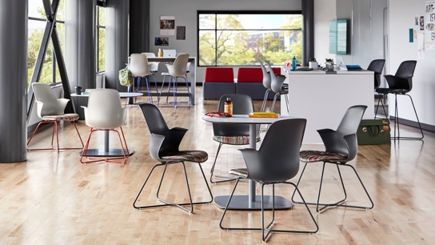
A Health, Safety, Welfare Learning Seminar

Designers Units: 0.1
IDCEC Designation: HSW

Architects Units: 1
Course Number: SC0845
AIA Designation: HSW

There is growing concern for student and educator wellbeing and the challenges each are facing, making it difficult for each group to do their best learning and teaching. New research helps you better understand and identify ways to center wellbeing in learning spaces.

Our research suggests that a person’s wellbeing is better understood as a confluence of physical, cognitive and emotional factors. The research identifies six pillars of human wellbeing that are universally true: meaning, belonging, authenticity, mindfulness, optimism and vitality. Additionally, the dimensions of what impacts our wellbeing are intrinsically connected to our personal relationships and the people/environments around us.

Contact your Steelcase representative for more information.

