PRODUCTS: RW
SYMPTOMS: Roomwizard Firmware 4.7
OS’s: NA
KEYWORDS: Roomwizard FTP Backups to capture Watchdog failures
RoomWizards now include an option to Backup FTP Logs whenever RoomWizard Watchdog failures happen. This forces RoomWizards to send Logs to the FTP Server, and allows administrators to analyze the Watchdog Logs to determine potential causes of the Watchdog failures or a time frame for when they occurred. If no Watchdog failures occur, then no Watchdog Logs will be generated. Watchdog failures are uncommon, though the logs they generate provide value for debugging Watchdog failures of unknown cause.
NOTICE REGARDING FTP VERSUS SFTP: It is important to note that as of FW 4.7 that the FTP Protocol is disabled for both outbound and inbound network traffic. This means that SFTP will be used in place of FTP resulting in a more secure connection. To accommodate this change the remote FTP server must be configured to accept SFTP network traffic. If the remote server is not configured to use SFTP the configuration could fail. FTP can be used in place of SFTP by enabling FTP on the RoomWizard though SFTP is recommended for security reasons.
Configuring FTP via the RWAC: The RWAC is a convenient way to setup a FTP Server to capture Watchdog logs for a RoomWizard or Group of RoomWizards. This can be accomplished using the Configuration Tab(for a single RoomWizard only) or the Right Menu Bar(for both single and Groups of RoomWizards).
Configuration Tab Option: To enable FTP Watchdog Logs using the RWAC highlight a RoomWizard. Once highlighted access the Configuration Tab for the RoomWizard on the lower right corner of the RoomWizard. The option for enabling FTP Watchdog Logs is listed as “Send Logs via FTP/SFTP in the RWAC and is off by default as shown below.
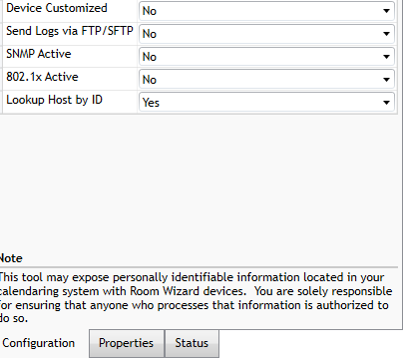
Once this option is set to yes a dialog box appears with settings for enabling Watchdog as well as entering in a FTP Server IP Address as well as a username/password. See next page.

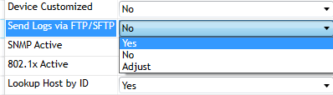

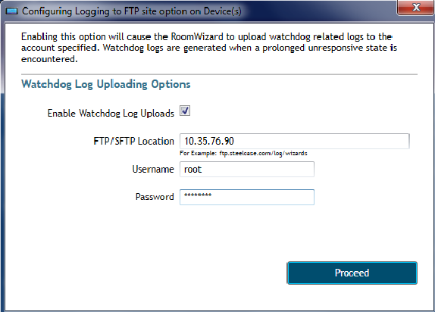

The configuration is displayed above. Enable the checkbox and enter in the IP Address of the FTP Server and the directory if necessary. If only the IP Address is entered that implies that logs will be dropped in the default root location for the specified FTP Server when Watchdog Logs occur.

Once the Proceed Button is clicked the RWAC will process the request to configure FTP Watchdog Logs. If the configuration is successful the RWAC will display the following dialog box:

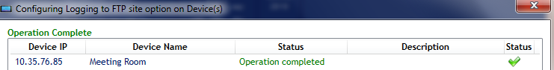

Configuring Watchdog Log files by the RMB Option: Watchdog Logs can also be configured by right clicking a RoomWizard or Group of RoomWizards and choosing the Configure (Multiple) Replicate Option and selecting the Configure sending WD Logs via FTP/SFTP. This will open the same dialog box as seen when configuring Watchdog Logs via the Configuration Tab but this option is used for both single and Groups of RoomWizards.

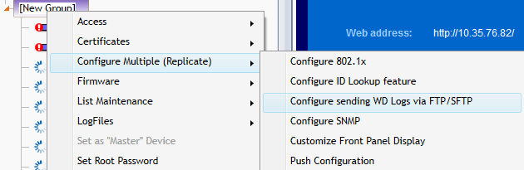

If an error occurs the following dialog box appears:

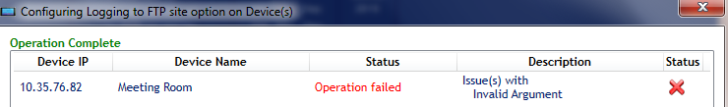

The root cause of these errors is mentioned below:
- Server offline: The server itself might not be accessible. Check that the server is online.
- Mismatch between protocols: The server might not accept the default SFTP network traffic. Check that both the RoomWizard and FTP Server are both using the same protocol(either FTP or SFTP).
- Username/Password errors: There could be an issue with accessibility due to invalid usernames and passwords. Verify that these are correct.

Viewing Watchdog Logs: Once Watchdog Logs are enabled, the Watchdog Logs only appear when Watchdog errors occur on the RoomWizard. If a RoomWizard is experiencing errors of any kind, check the FTP Server location to see if Watchdog Logs were generated. If so, the Watchdog Logs will appear as a zip directory on the FTP Server as shown below:

