PRODUCT: RoomWizard Firmware 4.7
NEW FEATURE: Simple Network Management Protocol (SNMP)
KEYWORD: RoomWizard SNMP Configuration.

RWAC Configurations for SNMP

SNMP is a feature with a significant role in RoomWizard firmware version 4.6 that has been greatly expanded in RoomWizard firmware version 4.7. SNMP was expanded to include better security enhancements. Changes have been made to the RWAC to allow efficient configuration of this feature without having to navigate to the RoomWizard Admin Pages.

How to configure SNMP:
SNMP (Simple Network Management Protocol) is a network protocol that sends basic information about the status of RoomWizards to a centralized SNMP Manager that oversees all RoomWizards on a network. Once RoomWizards are configured for SNMP, the SNMP Manager can be used to generate Walks and Traps.
- Walks are run manually by an administrator and used to gather general information about a RoomWizard such as its MAC Address and Classic/Connector Mode status.

- Traps are alerts that are sent automatically whenever a RoomWizard faces a status change or error condition of some sort. For instance if a RoomWizard changes from Classic to Connector Mode an SNMP Trap network packet will be sent from the RoomWizard to the SNMP Manager stating this change in status. This packet will be captured by the SNMP Manager where it can be viewed in a user-friendly format to see the status change of the affected RoomWizard(s). If the RoomWizard(s) are stable with no changes or errors, it is possible to never see any SNMP Trap messages from a RoomWizard on the SNMP Manager.

Configuring SNMP using the RWAC:
There are two versions available of SNMP for configuration using the RWAC:
- SNMPv2
- SNMPv3.
- While SNMPv1 is available for configuration in the Admin Pages, it is a security liability and is not recommended for configuration.

SNMPv2 Configuration
SNMPv2 is simple to configure. The fields are described below:
- RW Location: This field is optional. This is used to record the RoomWizards location.
- Local RW Contact: This field is optional. This is used to record the RoomWizards Contact Person.
- Manager (Approved IP List): This is used for configuring the SNMP Manager. This field is required for SNMP Traps but not SNMP Walks.
- Community String: This is essentially the password for SNMP Walks and Traps. This password can remain consistent for all RoomWizards on the network if desired. The Community String configured in the SNMP Manager should match the Community String configured on the RoomWizards. A mismatch means that Walks and Traps will not be viewable from the SNMP Manager.

To configure SNMPv2 on an individual RoomWizard.
- Highlight the RoomWizard
- Click on the “Configuration” Tab on the right side of the screen.
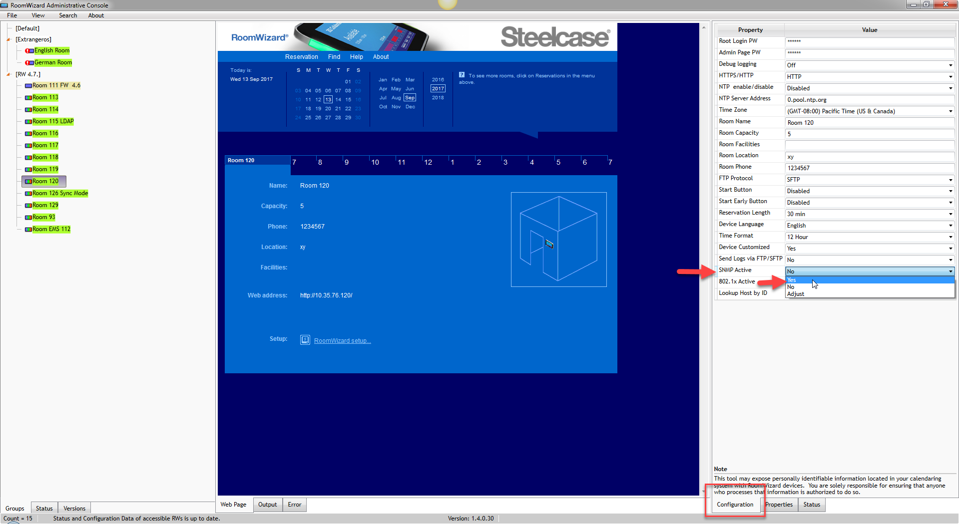
- Change the value of “SNMP Active” to “Yes”.
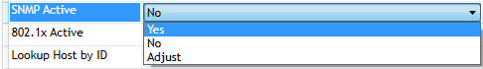

- This will open the following dialog box:
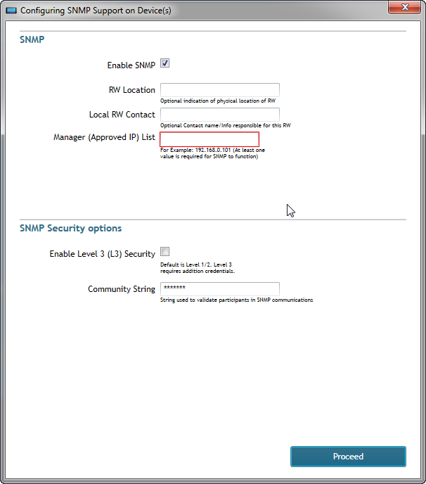
- Make sure that the “Enable SNMP” check box is selected.
- Configure all additional values “RW Location” and “Local RW Contact” as optional.
Note: Enter the “SNMP Manager approved IP Address” here. Note that a plus button appears after an IP Address is entered in the correct format.
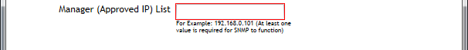
- Click the plus button to add the SNMP Manager.
Note: Multiple SNMP Managers can be added. The minus button will remove unwanted SNMP Managers.
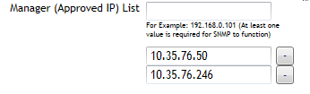
Once everything is configured, the final setup will look like the picture below (Note: the Enable SNMPv3 option is unchecked).
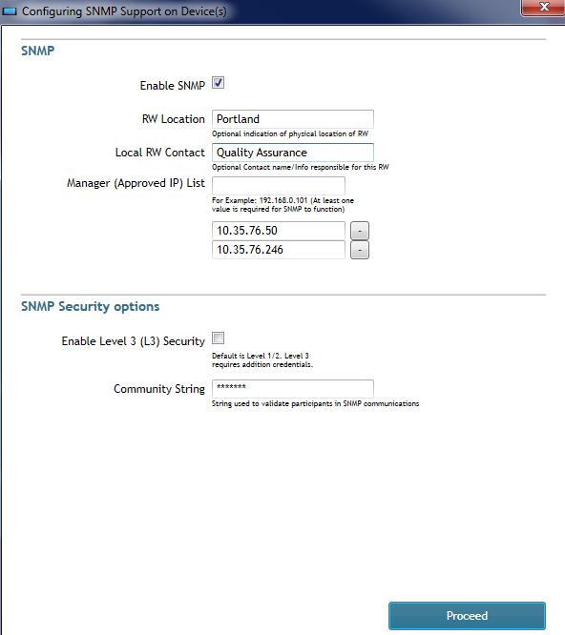

- Click the “Proceed” button to configure the RoomWizard with the selected SNMPv2 Settings.

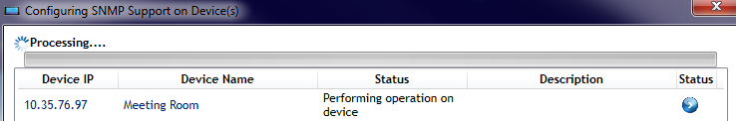
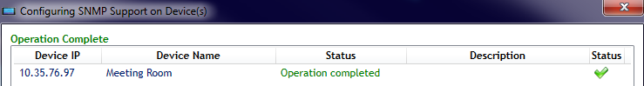
- Once complete the RoomWizard can be recognized using the SNMP Manager.

In addition to configuring SNMP from the “Configuration” Tab, The SNMP setting can also be configured in the RWAC by right clicking a RoomWizard (or a Group of RoomWizards) and selecting Configure Multiple (Replicate) -> Configure SNMP option.
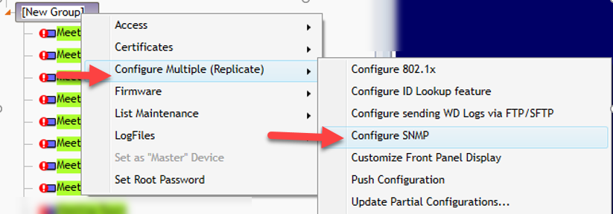
This method will display the same SNMP Configuration dialog box as the “Configuration” Tab, though this method allows SNMP to be configured on multiple RoomWizards at once.

SNMPv3 Configuration
SNMPv3 is the latest version available for RoomWizards on firmware 4.7. This version is more secure than SNMPv1 and SNMPv2, hence the setup being more complex.
The security enhancements for SNMPv3 are that the password is now encrypted and username is required along with a password. Different security algorithms of varying strength can be selected to enhance or modify security between the RoomWizards and the SNMP Manager.
NOTE: SNMPv3 Traps have proven to be compatible with the SolarWinds standalone utility only. The pictures below are captures provided by Steelcase IT using the SolarWinds standalone utility.
The fields for SNMPv3 are described below:
      - RW Location: This field is optional. This is used to record the RoomWizards location.
      - Local RW Contact: This field is optional. This is used to record the RoomWizards Contact Person.
      - Manager (Approved IP List): This is used for configuring the SNMP Manager. This field is required for SNMP Traps but not SNMP Walks
      - Enable Level 3 (L3) Security: This check box must be selected to enable SNMPv3(along with the Enable SNMP check box at the top).
      - Authentication Protocol: Protocol used for Authentication (SHA is more secure than MD5).
      - Privacy Protocol: Protocol used for Encryption (AES is more secure than DES).

NOTE: AES192 is not supported by SolarWinds for analyzing RoomWizard SNMP Packets. AES128 must be used instead.
- Privacy Key: Key string to use for encryption input.
- Security Name: This is essentially a username.
- Authentication Key: This is similar to a password.

Below is the display of the SNMP dialog box in the RWAC. Observe that the fields expand once SNMPv3 is selected.
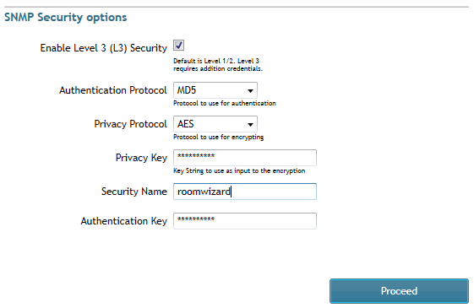
- Click the “Proceed” button.

Viewing SNMP traffic with the SNMP Manager using SolarWinds Tool.
Once the SNMPv3 settings are saved on the RoomWizard, SNMP must be configured using the SNMP Manager. To configure SNMPv3 using the SNMP Manager, an SNMP Manager Tool (such as the SolarWinds Tool) is needed.
NOTE: A Steelcase MIB will be needed if users wish to observe Walks/Traps in user friendly format. This MIB is available for download at the following location:
To view the SNMP Trap or Walk select either SNMPv2/SNMPv3 (depending on the version configured on the RoomWizard). Configure the SNMP credentials (such as Username, Authentication and Privacy Keys if using SNMPv3) to match the configuration made on the RoomWizard using the RWAC.
See picture below for reference.
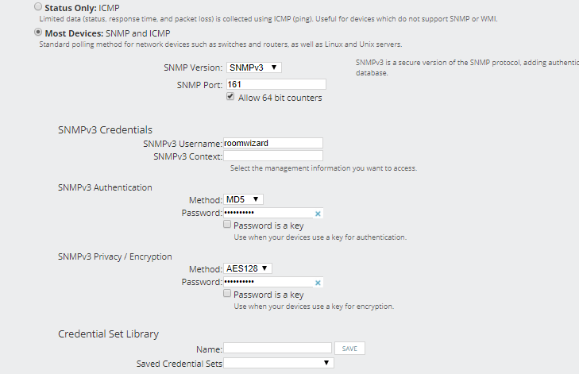
Once this is setup the RoomWizard is ready for Walks and Traps using SNMPv3. The SolarWinds Tool will display generated Traps as shown below.
These Traps will be generated whenever errors occur on the RoomWizard or a status change on the RoomWizard takes place.

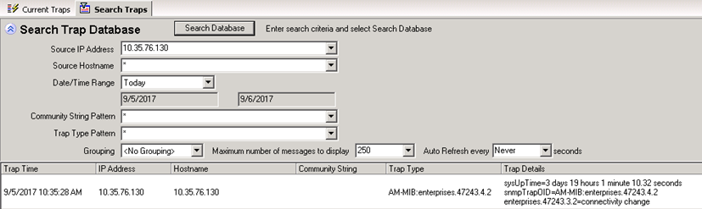

Steelcase Technical Support
If you have questions or difficulties, please call Steelcase Technical Support.
In the Americas, contact Steelcase USA Technical Support:
• Phone: 1.888.783.3522 Support available in English and Spanish
Monday through Friday
• Email: techsupport@steelcase.com

In EMEA, contact Steelcase Europe
- Phone: 00800.2000.4000 - DACH,France, Benelux, UK & Ireland
- +49.8031.405.111 - All Other EMEA Countries
Monday through Friday, From 7:30am to 18:30pm Central European Time
• Email: lineone-en@steelcase.com (English)
lineone-da@steelcase.com (German)
lineone-fr@steelcase.com (French)

In APAC, contact Steelcase Asia Pacific
• Phone: +60 3 2027 6161 Support available in English and Mandarin
Monday through Friday, 8:00am to 17:00pm KL Time
• Email: apac.techsupport@steelcase.com

