PRODUCT: RoomWizard Firmware 4.7
NEW FEATURE: LDAP (Lightweight Directory Access Protocol)
KEYWORD: RoomWizard LDAP

Configuring LDAP Using RWAC
LDAP is a new feature with a significant role in firmware 4.7. This feature allows users to populate the “First” and “Last Name” fields when scheduling Front Panel meetings by entering their corporate ID only.
This saves time and eliminates the need for the users to manually enter in their first and last names while creating Front Panel meetings. This option can be fully configured using the RWAC without having to navigate to the RoomWizard admin webpages. However, the LDAP feature may be configured on the admin webpages as well.

What is LDAP
LDAP (Lightweight Directory Access Protocol) is a network protocol that searches for basic information (such as users) residing in a database. It is often used in conjunction with Active Directory and should be installed in Active Directory domains. LDAP can search for different objects in Active Directory and speeds up the time it takes to find an object or to see if a specific object is present or not.

How to Configure the LDAP using the RWAC
LDAP can be configured using the RWAC. While LDAP can be configured in the webpages as well, the RWAC option is easy to administer.
- Open RWAC
- Highlight a RoomWizard running the latest version of firmware 4.7.
- Go to the “Configuration” Tab area
- Change the value of “Lookup Host by ID”
- From “No” to “Yes”.

- This will open “Configuring ID Lookup”
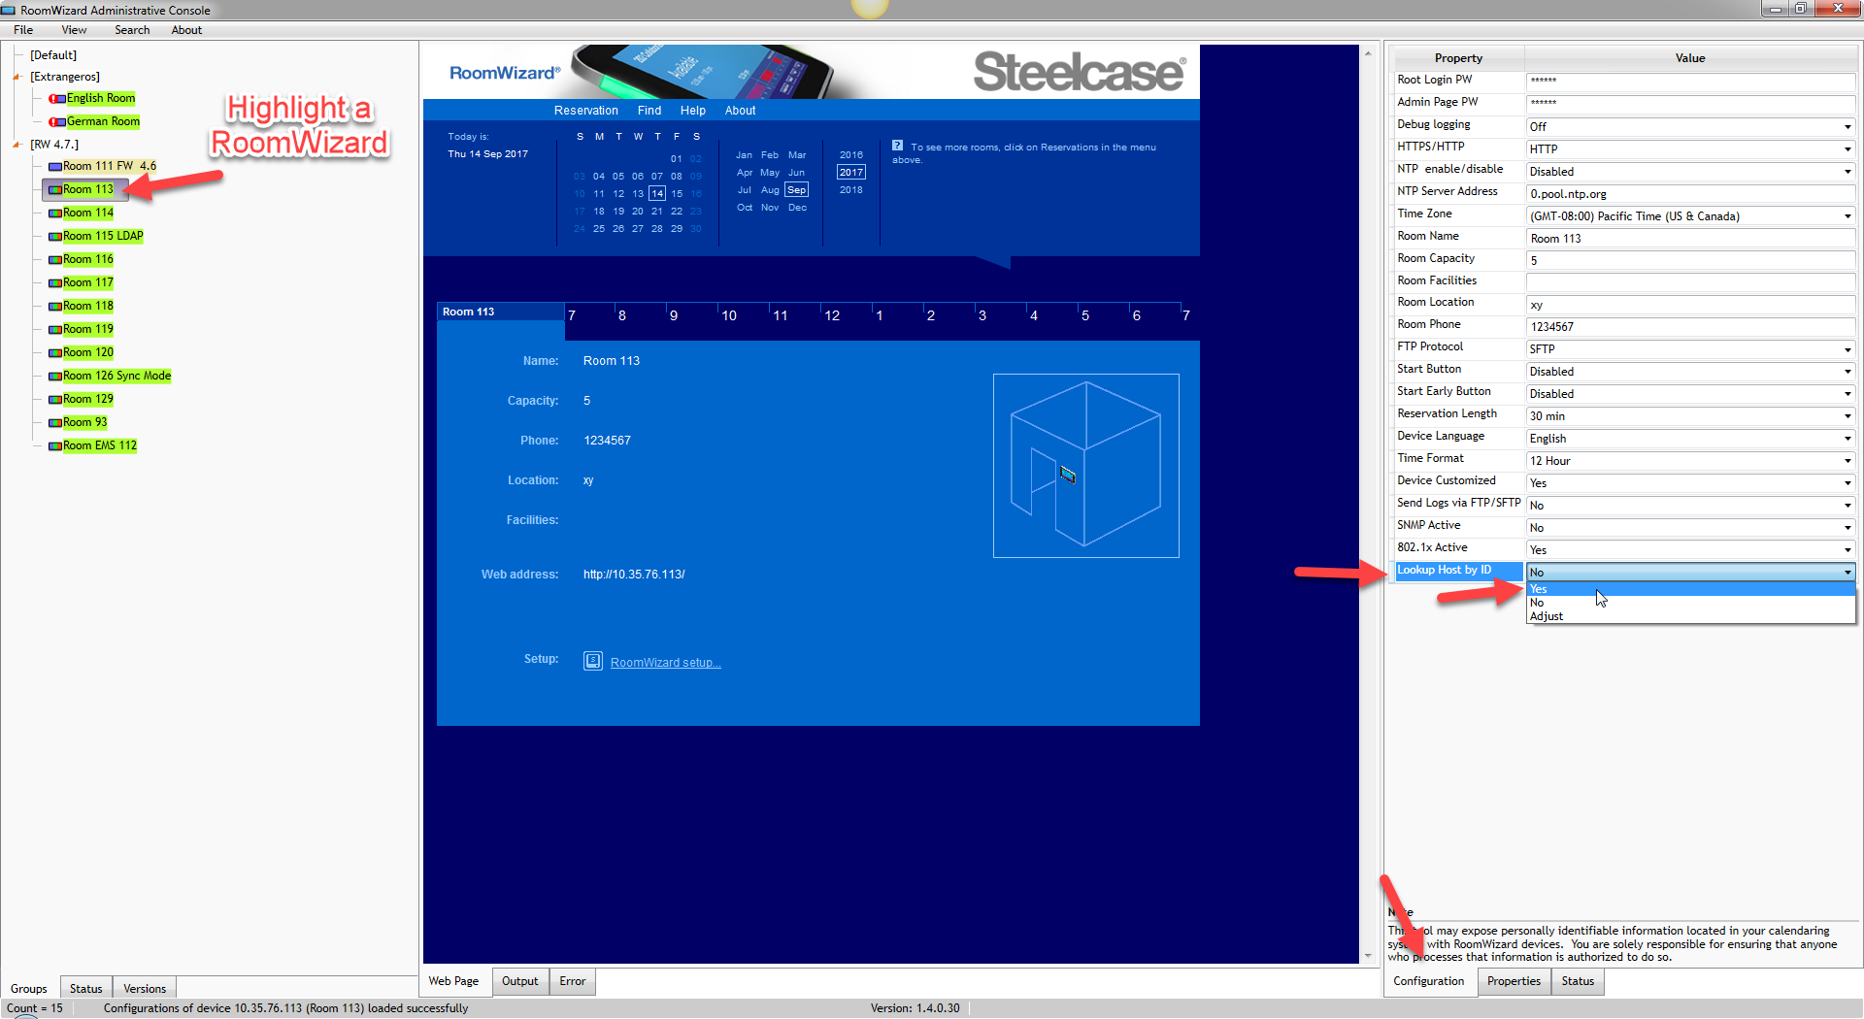
- Configuring ID Lookup via LDAP Device(s) will display the following dialog box:

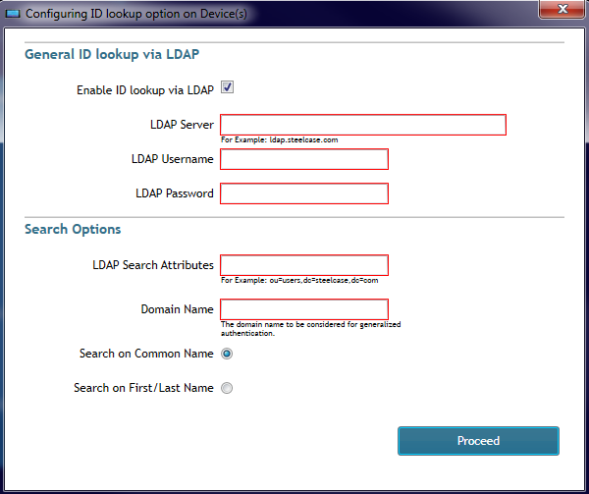

- Select “Enable ID lookup via LDAP” (This is used to enable the LDAP feature on the Front Panel).
- Enter the “LDAP Server” (The IP Address or FQDN of an LDAP Server)
- Enter the “LDAP Username” (The username of a user with administrative privileges on the domain. The username must be in the format domain\username to authenticate successfully)
- Enter the “LDAP Password” (The password of the LDAP user account configured above)
- Enter the “LDAP Search Attributes” specifying the OU or CN where email accounts reside.
For example: If we want to setup the RoomWizard to search attributes for users on a domain called “exch2016.com”, the format would be: “CN=Users,dc=exch2016,dc=com”.
- Enter the “Domain Name”: The format would be “domainname.com” (i.e. exch2016.com). This must be the domain name that the email accounts specify after the @ symbol.

- Select the “Search Options” or “Common Name”:
  - “Search on Common Name” (This options is selected by default).
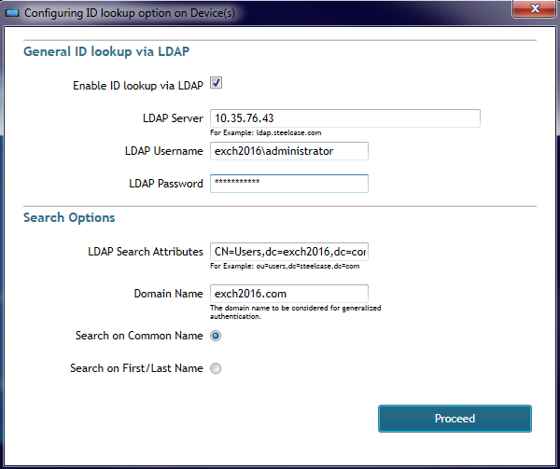
  - “Search on First /Last Name”

- Click the “Proceed” button to finish configuring LDAP.
- RWAC will then display the progress of the LDAP configuration as it finishes.

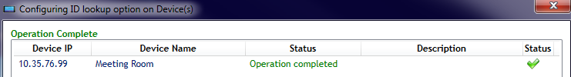

How to configure LDAP for a single unit or a group of RoomWizards
In addition to configuring LDAP from the Configuration Tab, LDAP can also be configured in the RWAC by right clicking a RoomWizard (or a Group of RoomWizards) and selecting the following options:
- Select option “Configure Multiple (Replicate)”
- Select “Configure ID Lookup feature”.
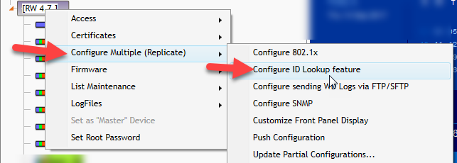
This method will display the same LDAP Configuration dialog box as the “Configuration” Tab, though this method allows LDAP to be configured on multiple RoomWizards at once.

Steps for how to use the LDAP Feature
Once LDAP is configured it will be enabled on the Front Panel whenever the “Use Now” or future timeline are clicked. This forces users to enter the “Network ID” in order to schedule a meeting.
To schedule a meeting, you must do the following when the LDAP feature has been enabled:
- Press the “Use Now” button
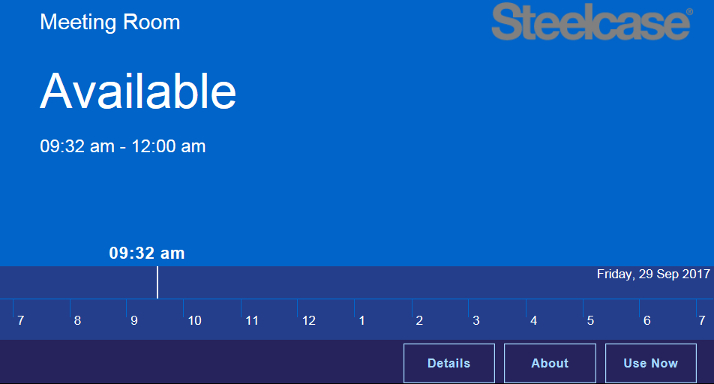
- Enter a valid “Network ID”
- The Network ID should correspond to the corporate username of a specific username without the @ symbol and the domain name.
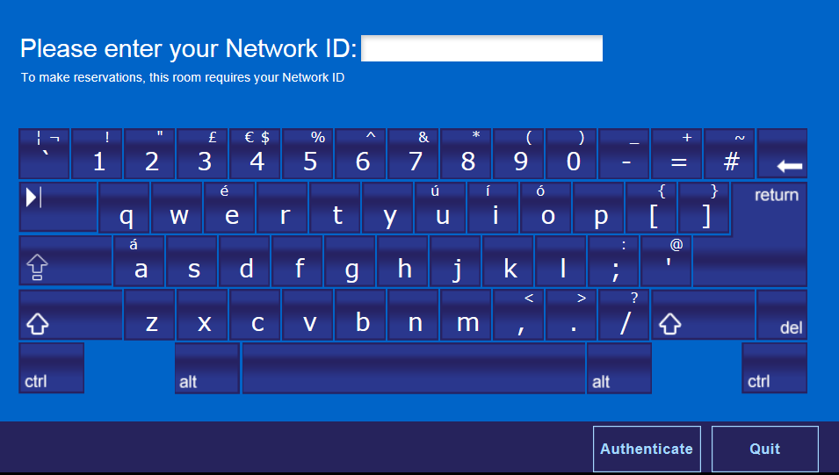

- For instance, if the username is “roomwizard”
- Enter “roomwizard” as a valid Network ID.
- This will allow the meeting scheduling process to continue.
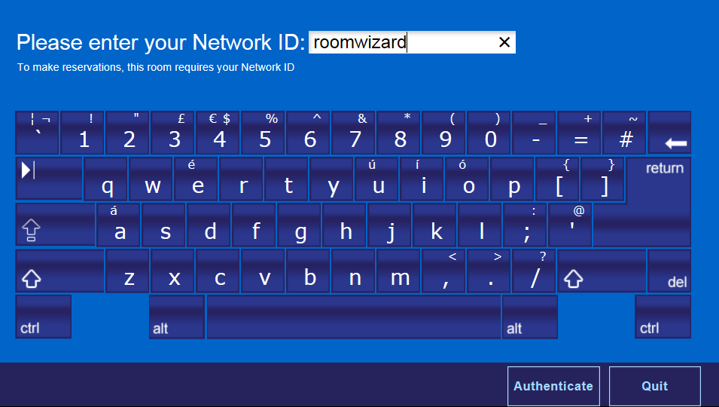
- Click the “Authenticate” button.
- Select the “+” to increase time or the “-“ to decrease the time for the meeting if is desired.
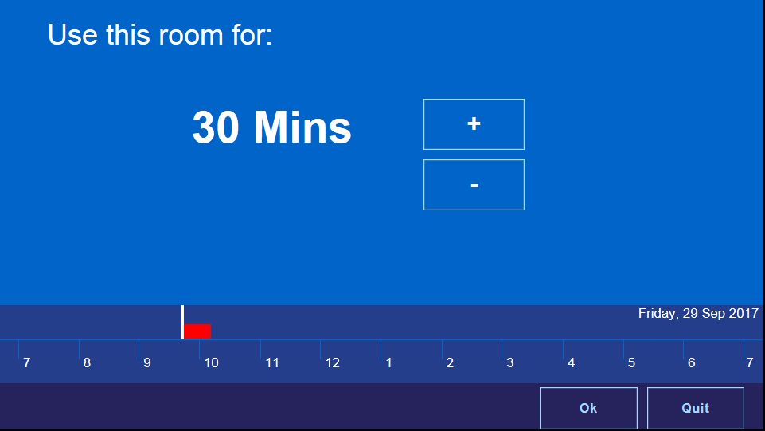
- Observe on the following screenshots how the “First” and “Last Name” fields are being populated.

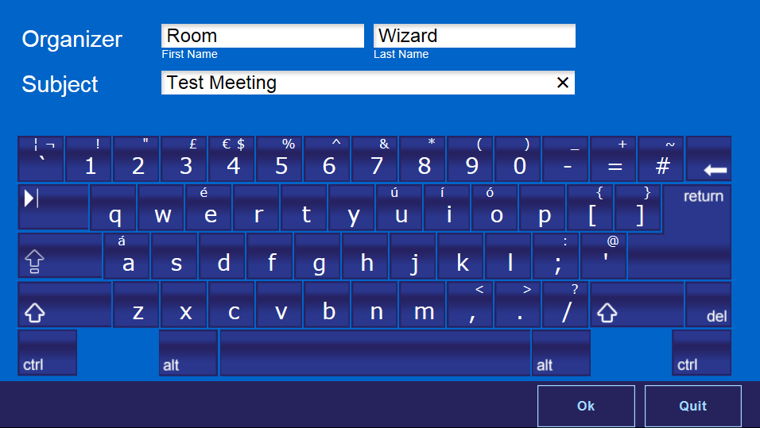
- Enter the subject of the meeting example: “Test Meeting”
- Click the “OK” Button
- The LDAP performed a search for “roomwizard” and displayed the correct “First” and “Last Name” after the search completed(in this case Room Wizard; No manual entry for the First and Last Name fields is required).
- The meeting appears on the Front Panel. Sample below:
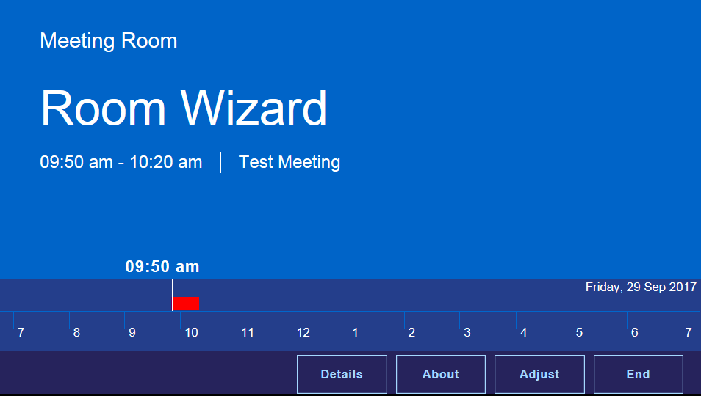
- The LDAP feature is also programmed to block invalid Network ID’s. Therefore, LDAP enabled meetings cannot be scheduled unless a valid Network ID is entered. View the images below and follow the steps below.
- Enter an invalid Network ID “tester”

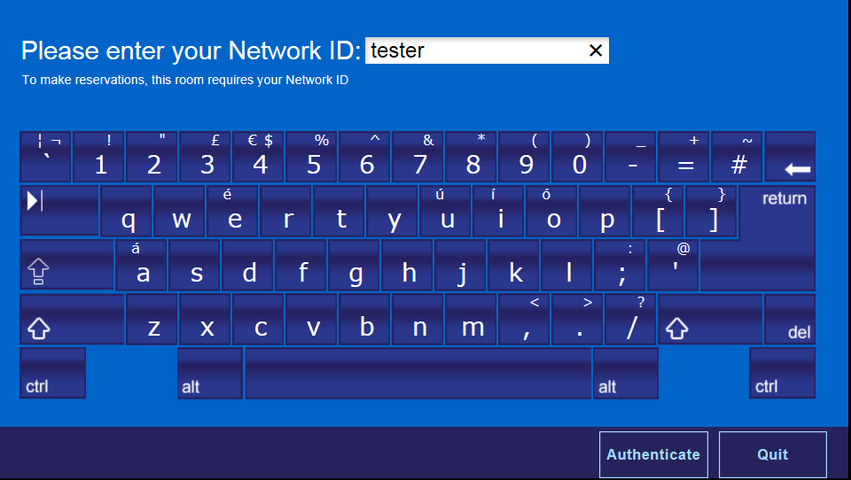

- If Authenticate is selected the meeting creation process cannot continue because the Network ID “tester” is not present on the domain configured for LDAP.

- The message “ Caution Please enter valid Network ID” will appear on the RoomWizard Front Panel.
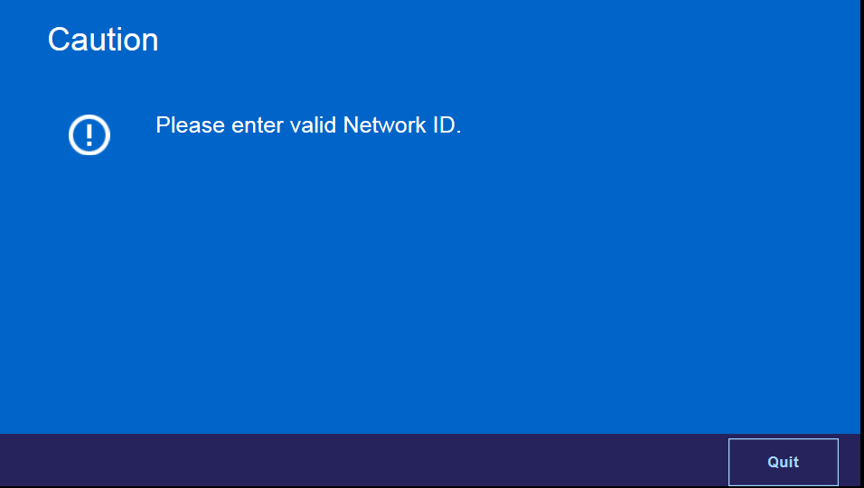

Steelcase Technical Support
If you have questions or difficulties, please call Steelcase Technical Support.
In the Americas, contact Steelcase USA Technical Support:
• Phone: 1.888.783.3522 Support available in English and Spanish
Monday through Friday
• Email: techsupport@steelcase.com

In EMEA, contact Steelcase Europe
- Phone: 00800.2000.4000 - DACH,France, Benelux, UK & Ireland
- +49.8031.405.111 - All Other EMEA Countries
Monday through Friday, From 7:30am to 18:30pm Central European Time
• Email: lineone-en@steelcase.com (English)
lineone-da@steelcase.com (German)
lineone-fr@steelcase.com (French)

In APAC, contact Steelcase Asia Pacific
• Phone: +60 3 2027 6161 Support available in English and Mandarin
Monday through Friday, 8:00am to 17:00pm KL Time
• Email: apac.techsupport@steelcase.com

