PRODUCTS: RW
SYMPTOMS: Roomwizard Firmware 4.7
OS’s:
KEYWORDS: Roomwizard Gradient and Logos changes via the RWAC
Recent upgrades to the RoomWizard Firmware now allow users to change the color Gradient of the RoomWizard Front Panel as well as add Logos to the Front Panel. This allows end users to have their own color schemes as well as specific Front Panel Logos that fit the needs of their organizations. Multiple colors can be shown on the Front Panel, and Logos support multiple extension types as well.
Configuring Gradients via the RWAC: The RWAC is the designated way to setup color Gradients and/or Logos for a RoomWizard or Group of RoomWizards. This can be accomplished using the Configuration Tab(for a single RoomWizard only) or the Right Menu Bar(for both single and Groups of RoomWizards).
Configuration Tab Option: To configure a Gradient and or Logo using the RWAC highlight a RoomWizard. Once highlighted access the Configuration Tab for the RoomWizard on the lower right corner of the RoomWizard. The option for configuring Gradients and Logos is listed as Device Customized. This option is set to No by default implying the default color scheme without any Front Panel Logos. See picture below.
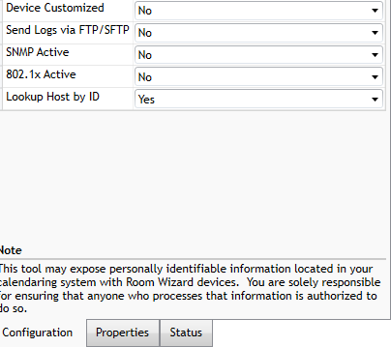
Once this option is set to yes the dialog box at the top of the next page is displayed.
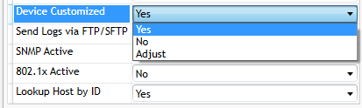

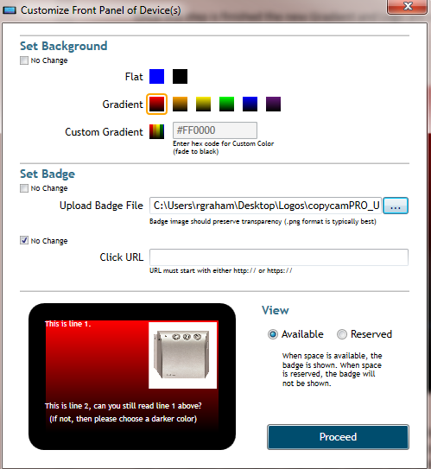

The configuration is displayed above. Choose the designated Gradient Color and Logo if desired. Once the selections are confirmed click the Proceed Button.

As the Proceed Button is clicked the RWAC will process the request to configure the RoomWizard with the selected Gradient.

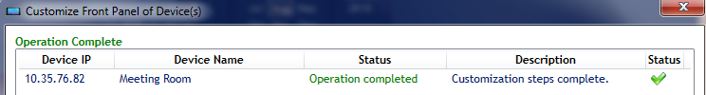

Once this step is finished the new Gradient and Logo are configured on the RoomWizard Front Panel as shown below:

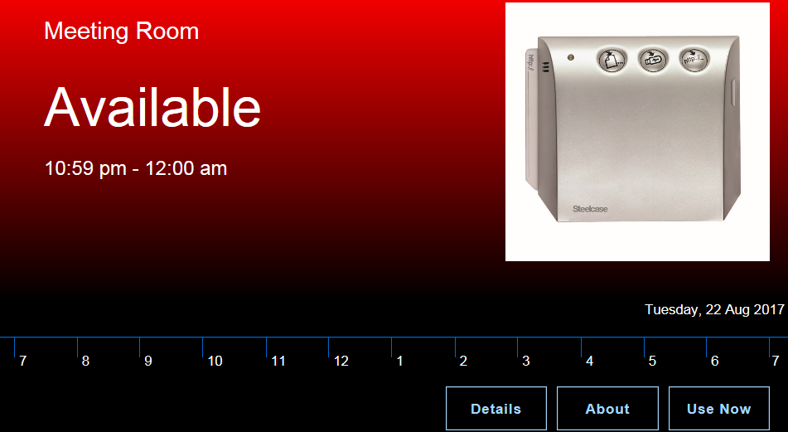

Configuring Gradients using the RMB Option: Gradients and Logos can also be configured by right clicking a RoomWizard or Group of RoomWizards and choosing the Configure (Multiple) Replicate Option and selecting the Customize Front Panel Display option. This will open the same dialog box as seen when configuring Gradients and Logos via the Configuration Tab but this option is used for both single and Groups of RoomWizards.

