PRODUCTS: RW
SYMPTOMS: RoomWizard Firmware 4.7
OS’s:
KEYWORDS: 802.1x KB Article
Due to security enhancements in network environments, 802.1x is now available as an authentication feature when connecting RoomWizards to a network. This provides security by forcing RoomWizards to possess the proper 802.1x credentials in order to obtain an IP Address and connect to the network, thus rendering them useless unless the RoomWizards possess the proper credentials.
802.1x requires three components: RoomWizards, an 802.1x capable switch, and an 802.1x Server. By default, RoomWizards that connect to a port on an 802.1x Server will be blocked from obtaining an IP Address by the switch. The switch will request the RoomWizard provide credentials to proceed with obtaining an IP Address. If no credentials are provided by the RoomWizard the switch will not allow the RoomWizard to obtain an IP Address. If a RoomWizard provides credentials to the switch, the switch will forward those credentials to the 802.1x Server(RADIUS Server) using its own credentials. If the RADIUS Server authenticates the forwarded credentials from the RoomWizard(via the switch) as valid, the RADIUS Server informs the 802.1x switch that the credentials are valid and the switch grants access to the RoomWizard. If the credentials are invalid the RADIUS Server informs the switch and authentication is disallowed.
802.1x Authentication Methods: 802.1x has multiple configuration methods that are available on the RoomWizard. These are described below.
PEAP: This authentication method utilizes a username and password that is setup on the RADIUS Server. The RoomWizard will need to be configured to match the credentials set on the RADIUS Server otherwise authentication will fail and the RoomWizard will not obtain an IP Address. Further a Certificate Authority can be added to the RoomWizard as well for enhanced security. This must match the Certificate Authority configured on the RADIUS Server otherwise authentication will fail. PEAP provides different security protocols for TLS Version(1.2 and 1.1), PEAP Version(Version 0 and Version 1), and Inner Authentication(MSCHAPv2, MD5, GTC). The dialog box with the variables for PEAP is displayed below:
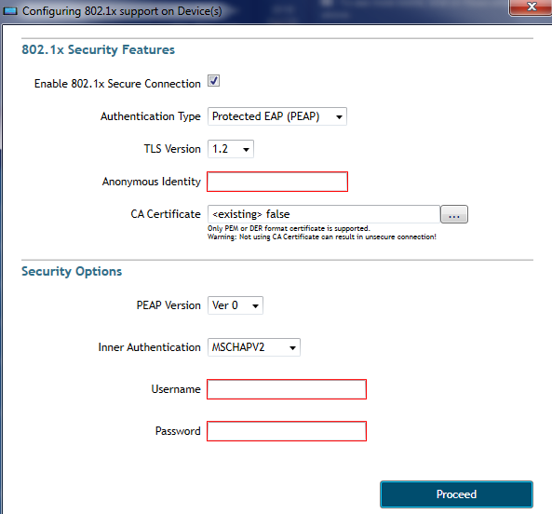
TLS: This authentication method utilizes a server(RADIUS) and client(RoomWizard) certificate that authenticate by exchanging certificates that possess the same mutual Certificate Authority. Once the certificates are exchanged between the RoomWizard and the RADIUS Server authentication proceeds and the RoomWizard may obtain an IP Address. The user certificate configured on the RoomWizard must be preconfigured on the RADIUS Server before exporting it to the RoomWizard. This includes the user certificate itself, as well as the private key for the user certificate and the affiliated Certificate Authority. If an incorrect user certificate is used, or if the private key and Certificate Authority are incorrect authentication will fail. TLS provides different security protocols for TLS Version(1.2 and 1.1). For the certificates, the user and Certificate Authorities can be in PEM of DER format. The private key can be in the formats of PEM, DER, P12, PFX. Note that the configuration will fail if the private key password is incorrect. The dialog box with the variables for TLS is displayed below:
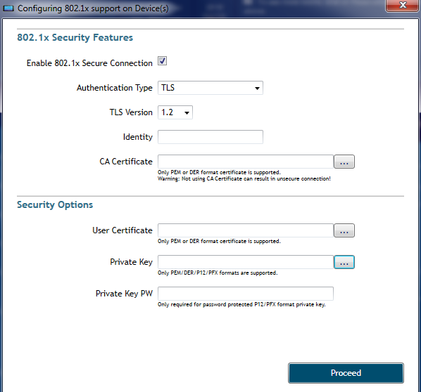

TTLS: This method is essentially the same as PEAP. This authentication method utilizes a username and password that is setup on the RADIUS Server. The RoomWizard will need to be configured to match the credentials set on the RADIUS Server otherwise authentication will fail and the RoomWizard will not obtain an IP Address. Further a Certificate Authority can be added to the RoomWizard as well for enhanced security. This must match the Certificate Authority configured on the RADIUS Server otherwise authentication will fail. TTLS provides different security protocols for TLS Version(1.2 and 1.1), and Inner Authentication(PAP, CHAP, MSCHAP, MSCHAPv2). The dialog box with the variables for TTLS is displayed below:
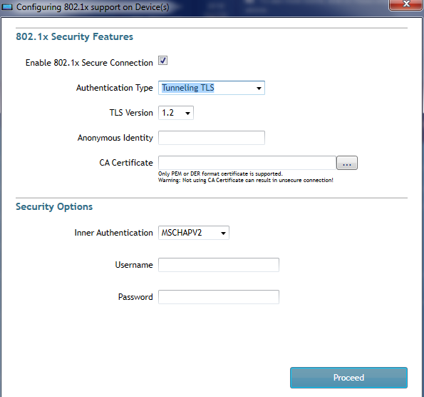

Configuration Tab Option: To configure 802.1x using the RWAC highlight a RoomWizard. Once highlighted access the Configuration Tab for the RoomWizard on the lower right corner of the RoomWizard. The option for configuring 802.1x is listed as 802.1x Active. This option is set to No by default, meaning that RoomWizards will not be able to obtain IP Addresses when connecting to ports and switches configured for 802.1x.
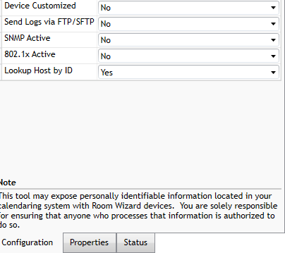
Once this option is set to yes the dialog box is displayed.
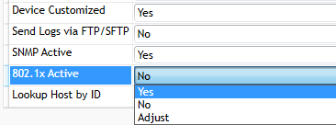
The configuration options are described above in the sections for PEAP, TLS, and TTLS. Set the desired protocols, upload the Certificates if required, and click the Proceed Button.

As the Proceed Button is clicked the RWAC will process the request to configure the RoomWizard with the selected 802.1x options.

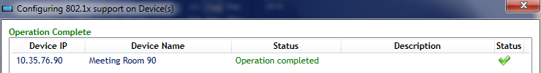

Configuring 802.1x using the RMB Option: 802.1x can also be configured by right clicking a RoomWizard or Group of RoomWizards and choosing the Configure (Multiple) Replicate Option and selecting the Configure 802.1x option. This will open the same dialog box as seen when configuring 802.1x via the Configuration Tab but this option is used for both single and Groups of RoomWizards.

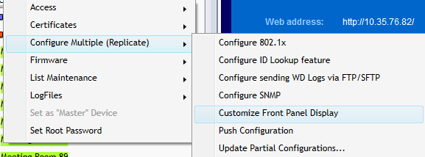

After the RoomWizards are properly configured they can be plugged into the ports on the 802.1x switches and successfully authenticate and obtain IP Addresses.

