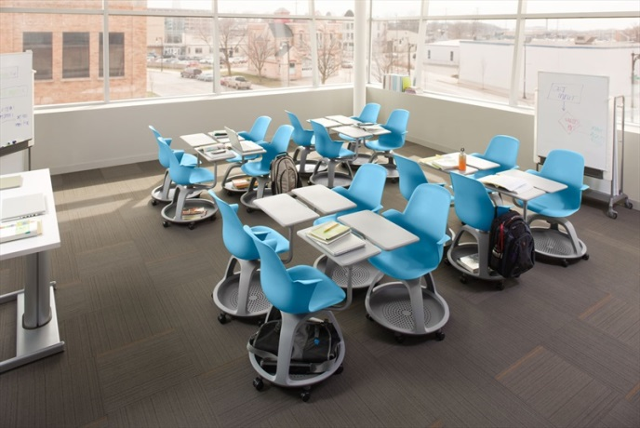
Today’s students expect more from their classrooms than ever before. They want their surroundings to support co-learning, co-creation and open discussion. Educators are often faced with a tough choice: promote active learning or organize a classroom to fit as many students as possible.

The Node chair is mobile and flexible. It’s designed for quick, easy transitions between room configurations. With Node, a classroom can flex from a lecture-based mode to a team-based mode, and back again, without interruption. Node can take passive space and make it active, supporting active and team-based learning, even when student density is important.

Why choose Node™?
Move: The Node chair is highly mobile, a quality that translates directly into classroom performance. The swivel seat gives students the freedom to shift focus throughout the room. And, because the personal worksurface swivels in tandem, books, laptops and other information remain at their fingertips. Clear sight lines to the instructor, fellow students and whiteboards can dramatically enhance interaction.

Store: The base of the Node chair provides a unique storage solution for backpacks and other belongings that usually clutter the aisles. This allows quicker and easier transitions between teaching modes. Even the arms serve a storage purpose by allowing a backpack or bag to hang close at hand.

Fit: The Node chair has an adjustable worksurface, providing a perfect fit for students of all shapes and sizes. The Node chair’s worksurface accommodates both left and right-handed users and the plastic seat shell can bend and flex with the student.

Key Features:
- Casters lend mobility for quick easy transitions between teaching modes
- Swivel seat keeps open sightlines between student and instructor, whiteboard, and other students
- Personal worksurface swivels in tandem with the seat and is adjustable for users of all sizes. It accommodates left and right-handed students and is large enough to support students’ digital and analog resources
- Tripod base keeps backpacks and belongings out of the aisle and off the floor
- Five-star base provides seat-height adjustability
- Node mid-back supports active learning in high-density classrooms. When students are forced to move against the wall, it helps to minimize contact.
- Optional cupholder and tablet stand free up worksurface area for books and technology
- Flexible seat keeps students comfortable in a variety of postures
- Open seat design offers easy access, while arms serve as backpack hooks
- Comfort without upholstery means easy maintenance
- Steelcase warranty with elevated durability testing

Environmental Impact:
Node is composed of materials approved by McDonough Braungart Design Chemistry (MBDC) as safe for human and environmental health. Node has achieved Cradle-to-CradleTM silver certification and a complete life cycle assessment. It has BIFMA Level 2 certification as well as Indoor Advantage Gold certification from Scientific Certification Systems.

